UNIVERSITY OF ENGINEERING AND TECHNOLOGY MARDAN


Data Mining Lab: 05
Muhammad Ismail
23MDBCS415
Department: CS (Data Science)
6th Semester

Upload Dataset
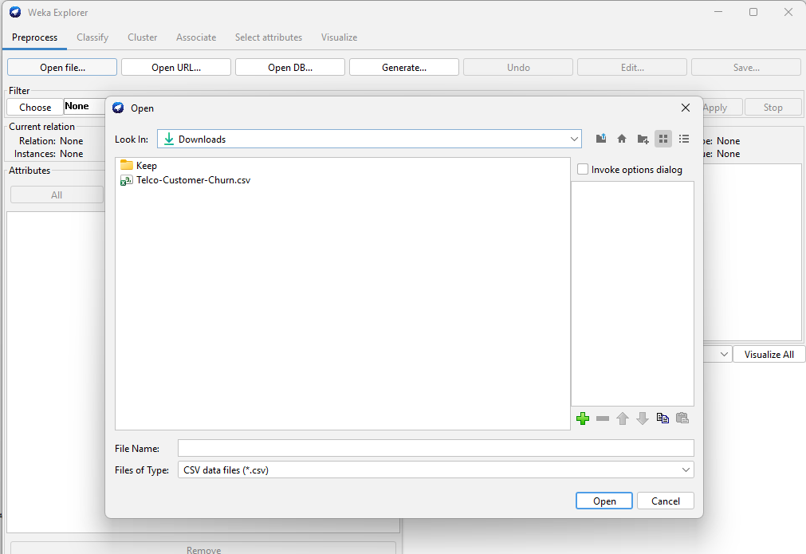
Replace Missing Values
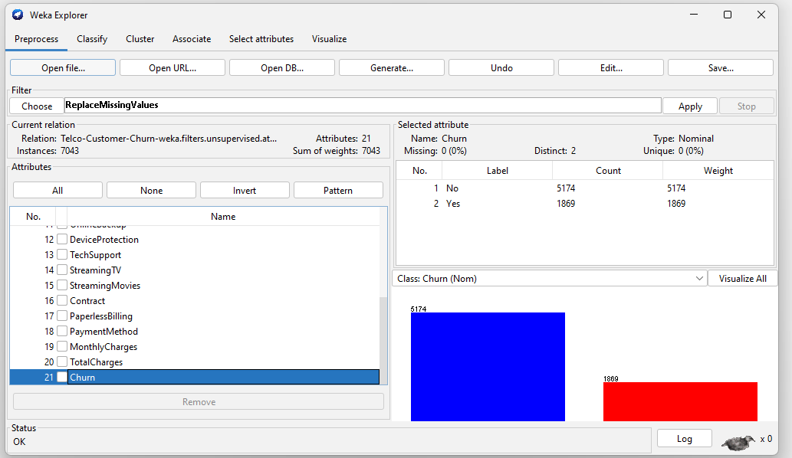
Discretization
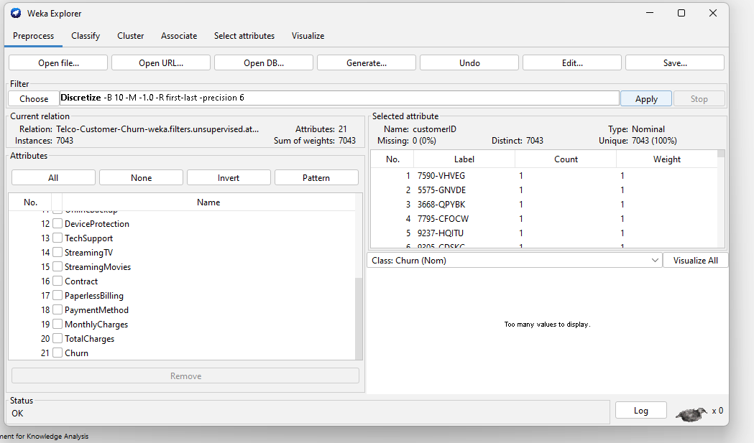
Normalization:
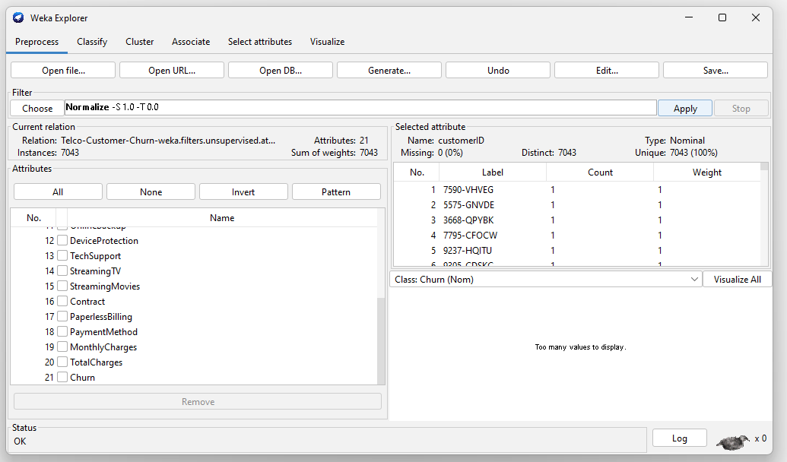
Binarization:
